- Introduction

- Outlines
- God’s Commands to assemble the Tabernacle (v1-15).

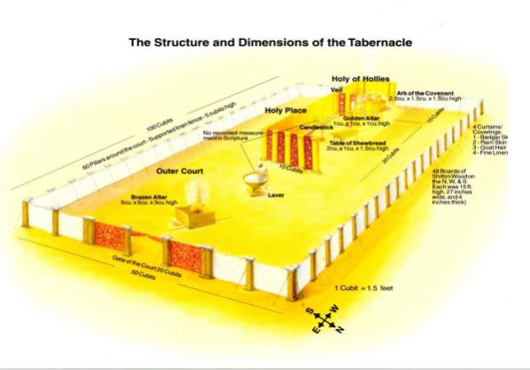
- Moses’ Obedience in assembling the Tabernacle (v16-33).

- God’s Glory fills the Tabernacle (v34-38).

- Conclusion

- Moses and the Israelites responded to God in generous, meticulous obedience. How should it affect you to do likewise as people who have seen the fullest revelation of God in the life and work of Jesus Christ?
- What work has God given you that you may be tempted to “cut corners” and not doing what you should be doing exactly? What will you ask God to enable you to do exactly as He has commanded you and to do everything His way, for His glory?
- Our body is the temple of God where the Spirit of God dwells. What areas in your life do you need to repent in order to live out the consecrated life that rightly reflects God’s glory?
- How does the reality of Christ bringing the greater fulfilment of the tabernacle changes the way you view your own worship and service to God today?
- How does willing service and worship of the Israelites changes the way you view your own worship and service of God today?

