Exodus 40 – Redemption Plan Fulfilled & Being Fulfilled!

Introduction

Exo 25:8-9
Exo 40
Exo 32
Exo 34
Command given
Instructions for the building of the tabernacle
Disruption caused by the building of the golden calf
Command accomplished
Resumption of the building of the tabernacle

- God instructed Moses to set up and to sanctify the tabernacle (Exo 40:1-15)

- Moses obeyed God’s instructions fully (Exo 40:16-33)

- God dwelled in the midst of His people (Exo 40:34-38)

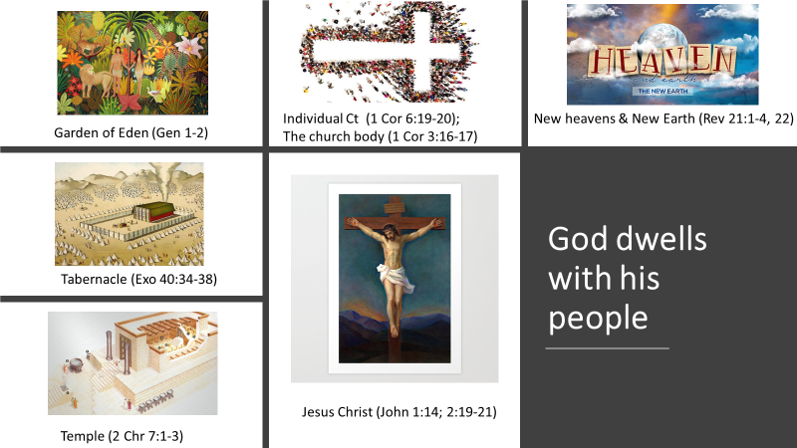

Reflection Questions:
- How does God dwell among us and lead us as NT saints today?
- What does it mean for the church (the temple of God), individually and corporately to be sanctified for God’s service?

